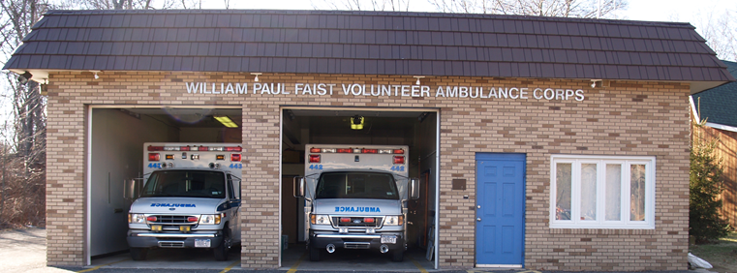
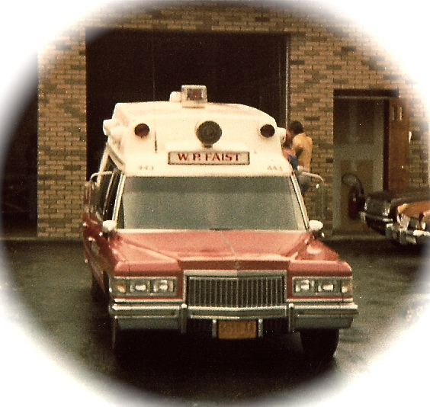
EMS UPDATE
The Community Newsletter of The William Paul Faist Volunteer Ambulance Corps

The members of the William Paul Faist Volunteer Ambulance are launching the first edition of EMS UPDATE as an outreach to the residents of the Village of Chestnut Ridge. We hope to bring you the latest Emergency Medical Service news within the village, the town, and the county. What’s happening at the Corps, medical tips that the whole family can use, first aid training available to the community, membership information, and tidbits that anyone can suggest.

We plan to publish the newsletter every now and then in an attempt to keep the news fresh and not bore you to tears. If you have a story or village information that you might think is newsworthy, please write the Corps at 3 Red Schoolhouse Road, Chestnut Ridge, 10977, attention EMS Update.

Ever see cars driving around the neighborhood with flashing green or blue lights when it’s not the holidays and wonder what they mean? Aliens no, strange maybe, but that’s another story. These are warning lights permitted by New York State for EMS and Fire volunteers responding to or working at an emergency. Green lights are for EMS and blue lights are for Fire. New York State Vehicle and Traffic Laws (V&T) states that these are courtesy lights and the volunteer is requesting that you let them pass. Because we are located on the NY/NJ State line, please note that New Jersey V&T states that you must give way to the volunteers. All New Jersey volunteers use blue lights.

Green Lights, Blue Lights “ALIENS”?

Issue, Date

Issue #1, 2010
“We’ve come a long way baby”
Circa 1981

Check out our website for additional Corps news: www.faistvac.org
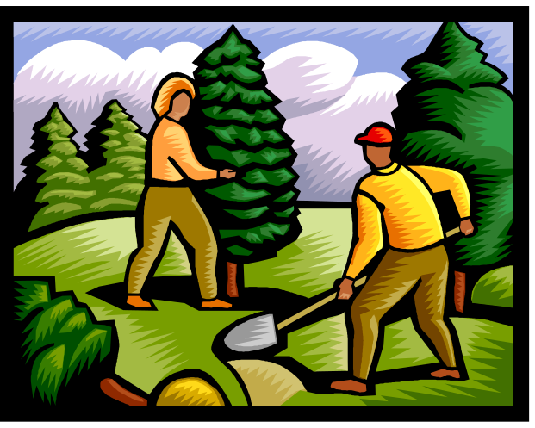
CLEANING FOR SAFETY
Household and pool
chemicals, paints, and
poisons should be
properly marked and
stored under lock and
key, and kept away
from children’s reach.
When cleaning up
hazardous materials
wear rubber gloves
and follow the safety
directions on the
package. Never mix
chemicals in the same
container. If you don’t know
how to dispose of them, seek outside advise. Never put them into the trash or pour down the drain.

With warmer weather and longer days approaching, people in Chestnut Ridge are emerging from their winter cocoons to focus on long-neglected projects like spring cleaning, home repairs, and yard work. Many are lacing up their shoes for their first outdoor walk or jog of the season. These activities can be extremely beneficial, but they also involve a variety of health and safety hazards that can be avoided with the proper precautions. To help ensure everyone in our community stays safe in the coming months, the members of the William P. Faist Volunteer Ambulance Corps offer the following tips and suggest you post them where they can be seen by your family.
CLEANING FOR SAFETY
- Household and pool chemicals, paints, and poisons should be properly marked and stored under lock and key, and kept away from children’s reach.
- When cleaning up hazardous materials wear rubber gloves and follow the safety directions on the package. Never mix chemicals in the same container. If you don’t know how to dispose of them, seek outside advise. Never put them into the trash or pour down the drain.

Spring and Summer Safety Tips
It is our goal to continue to enhance the emergency medical services we provide to Chestnut Ridge and YOU CAN HELP. We provide the uniforms, equipment, and the training. Now we are asking the community to give their time back to the Ambulance Corps.
The biggest benefit of membership in the Corps is the ability to help a neighbor in their greatest time of need and the sense of accomplishment and satisfaction when they say “thank you”.
Become an Associate member and help with the Corps committees or a Riding member and become a driver or EMT. We need whatever time you can give. Please call (845) 352-0735 ext. 416 or (845) 352-4556 ext. 416 and leave a message for the Membership Committee.

Why Volunteer?

Safety Tips continued on page 4
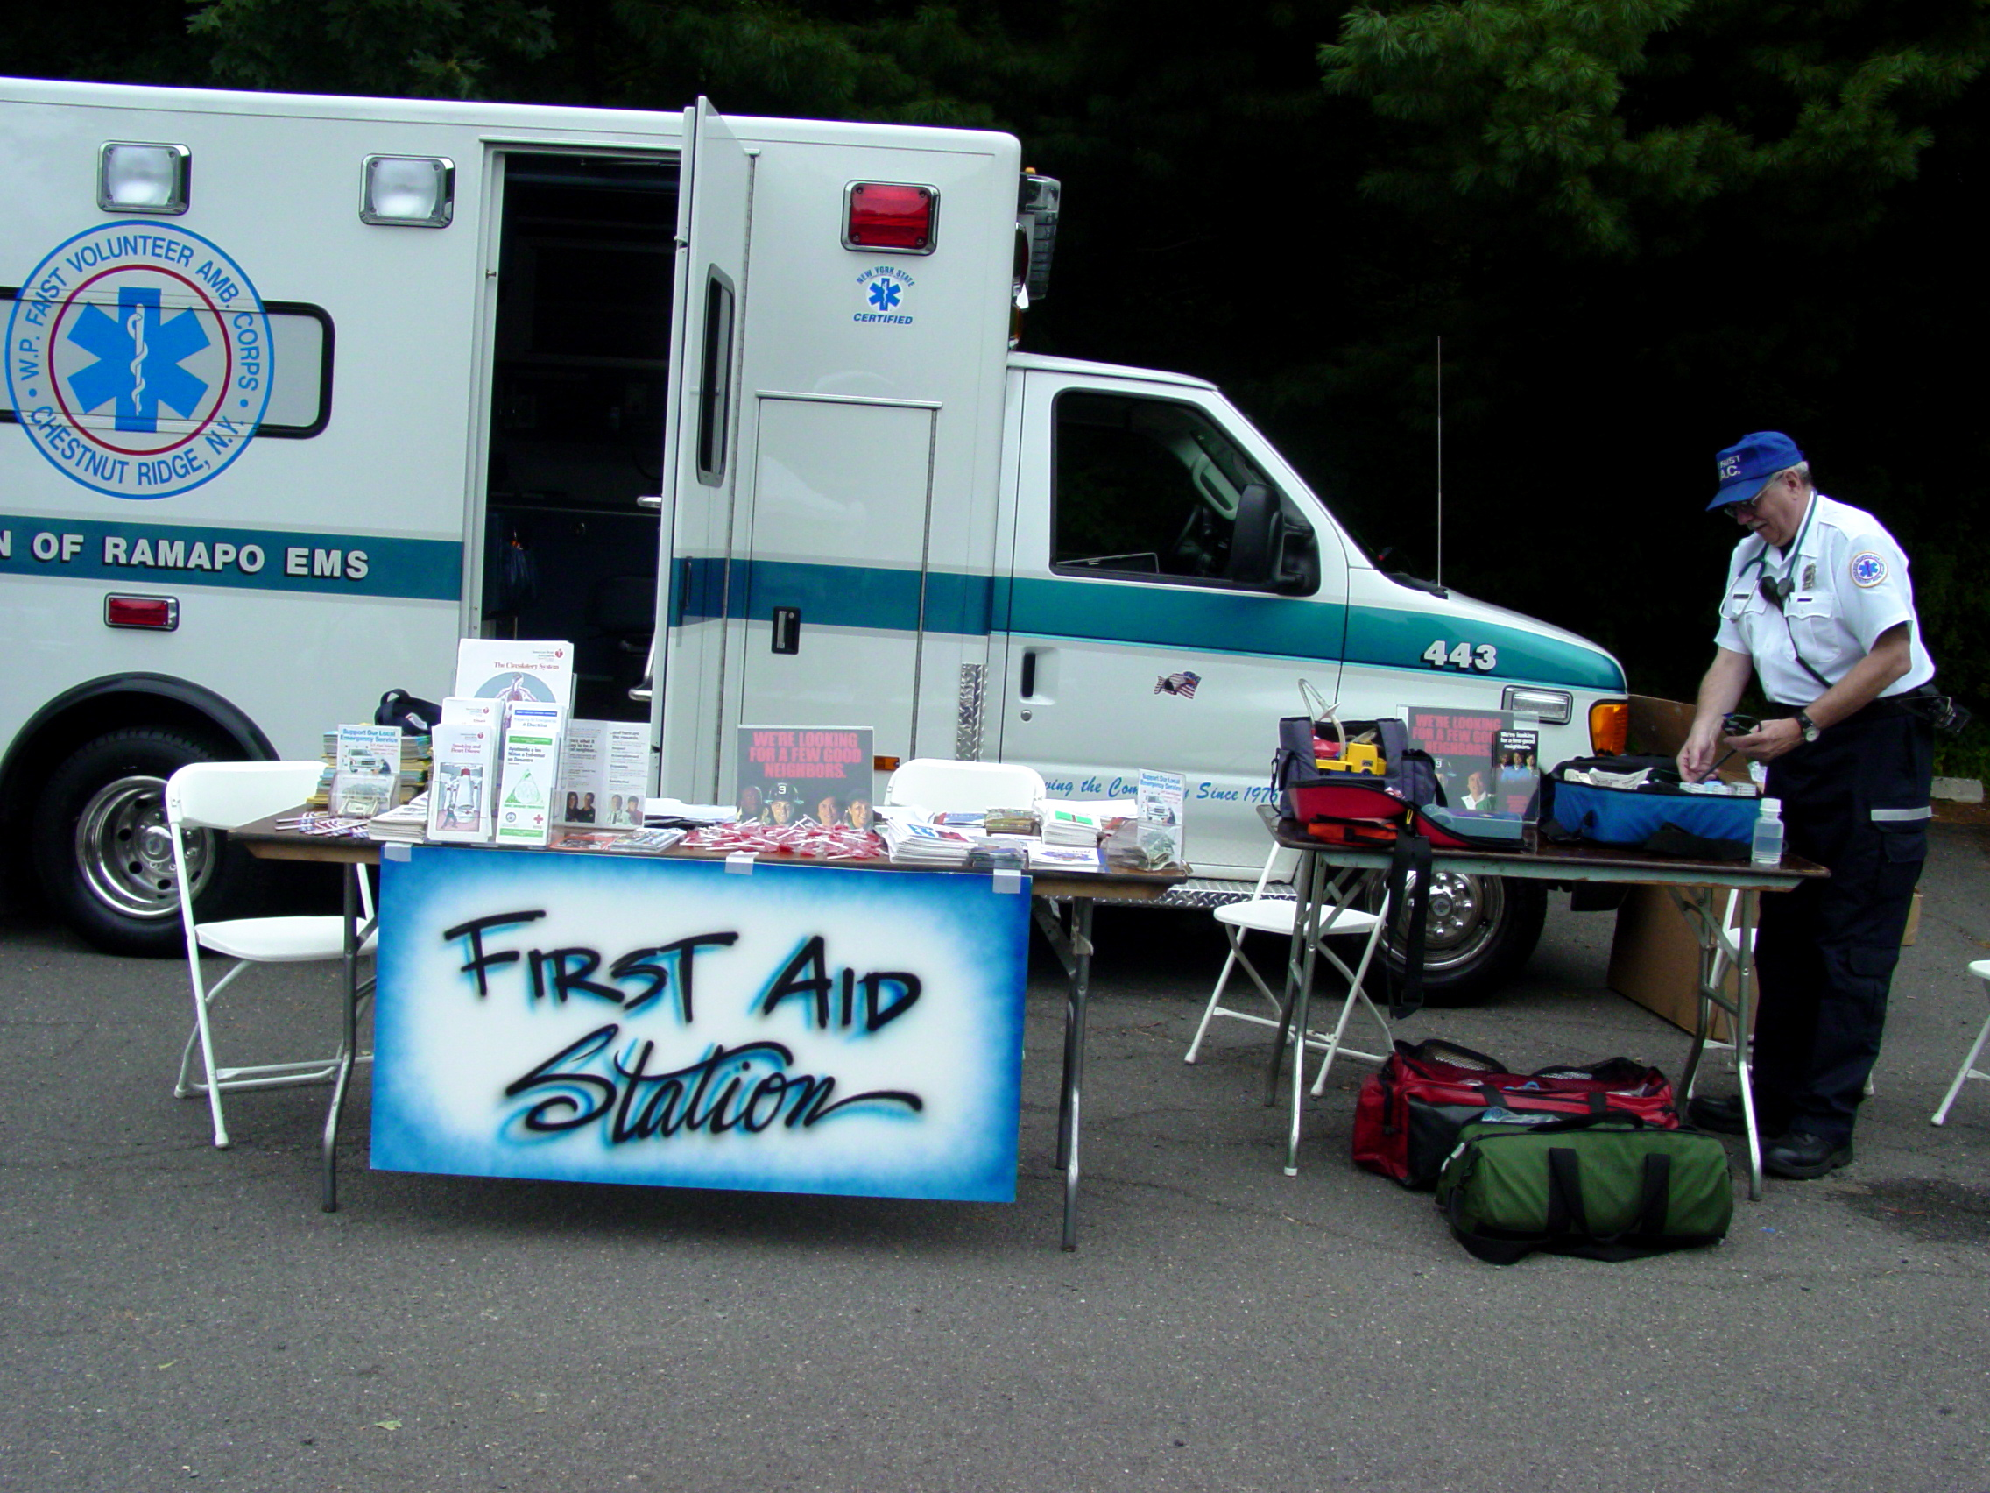
We can provide First Aid services or presentations for any community function.
- Never store hazardous materials on shelves above eye level.
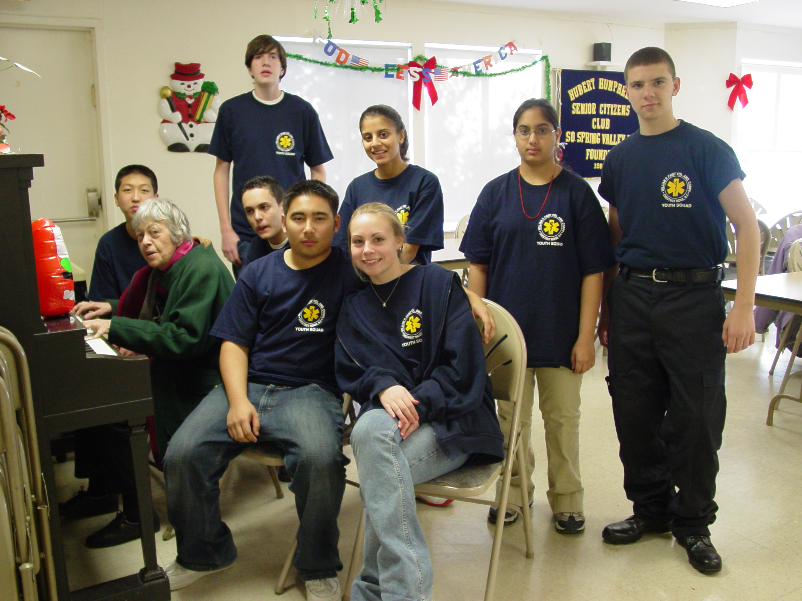

Did you know? We have revamped our Youth Squad and upgraded the program to a Junior Membership open to all teenagers between the ages of 15 and 18 years old. They are provided uniforms, CPR and first aid training. They are permitted to ride as a crewmember with parental approval and within certain time periods. After completing a one year probation period, the junior member will be permitted to vote on all Corps issues. A junior member may be able to take New York State CFR classes at age 16 and EMT classes after turning age 17 if they turn 18 prior to the completion of the final exams. Based on the junior member’s attendance at Corps functions, helpfulness and other tasks assigned, they may be eligible for high school community service credits. Please contact our Membership Committee or see our website for an application.

Become a Junior Member
Celebrate National EMS Week
May 16–22, 2010
You’re invited to our house!
Sunday, May 23rd from 12 P.M. to 5 P.M.
FREE FOOD, GIFTS & EMS DEMONSTRATIONS

YARDWORK SAFETY
- Limber up. Yard chores may seem easy, but they involve muscles you probably haven’t used in a while.
- Always wear protective clothing when you handle pesticides and fertilizers.
- More than 60,000 people are treated in emergency rooms each year for lawn mower injuries.
- When pruning trees, be careful not to let metal ladders or trimmers contact overhead wires.

HEAT

- Overheating can cause muscle cramps, chills, nausea and dizziness, among other things. At its worst, it can lead to heat stroke, a medical emergency.

Safety TipsTips (Continued)

- Drink plenty of water before and during hard or strenuous work in the heat. You’ll need more water than your thirst indicates.
SUN
- Protect yourself from the sun’s ultraviolet (UV) rays. Overexposure can lead to eye problems, sunburn and even skin cancer.
SWIMMING
- The Centers for Disease Control reports that drowning is the second leading cause of injury-related death among children 1-14 years old.
FOR ALL EMERGENCIES IN
ROCKLAND COUNTY CALL 911

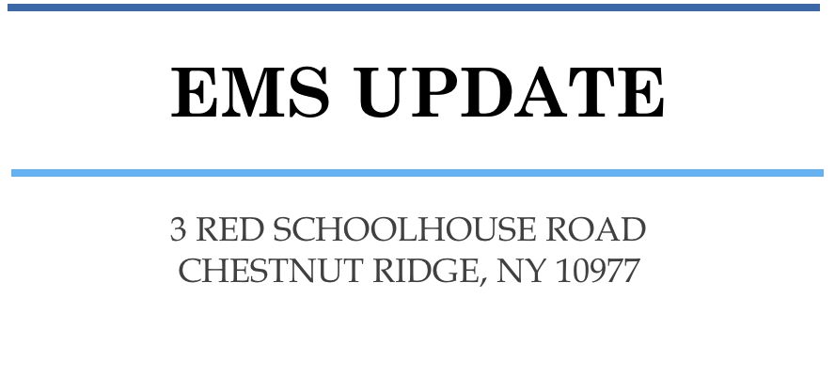
William P. Faist Volunteer Ambulance Corps
3 RED SCHOOLHOUSE ROAD
CHESTNUT RIDGE, NY 10977
EMS UPDATE

